Report on the eve of “WORLD STUDENT’S DAY”

Event Date: 18th October 2021

Event Venue: Physical Mode

Organizing unit/ agency/ collaborating agency: UICM (University Institute of Commerce and Management)

Name of the scheme: WORLD STUDENT’s DAY

Number of students participated in such activities: 100

Summary of Report:

The University Institute of Commerce and Management, Sant Baba Bhag Singh University, Jalandhar Organising activity on “WORLD STUDENT’S DAY”, 18 October 2021with the presence of honorable Vice Chancellor Dr. Paramjit Singh Parmar, Dean Institute of commerce and Management Dr. Seema Garg, HOD of the Department Dr. Sandeep Kaur Randhawa & all Faculty Members and students. The students of BBA, MBA, B.COM, M.COM taken active Participation in DISCUSSION, QUIZ COMPETITION AND PRESENTATION MAKING COMPETITION.
In the last session Dr. Sandeep Kaur Randhawa distributed Prize to the winning team of Discussion, Quiz competition and Presentation Competition.

Glimpse of the Event:

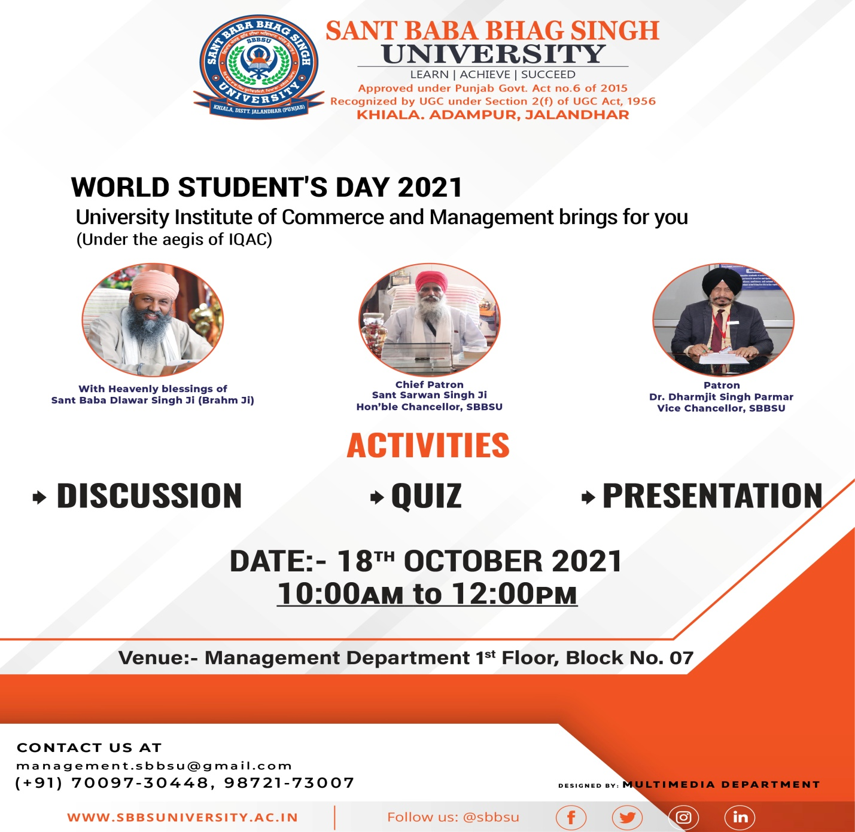

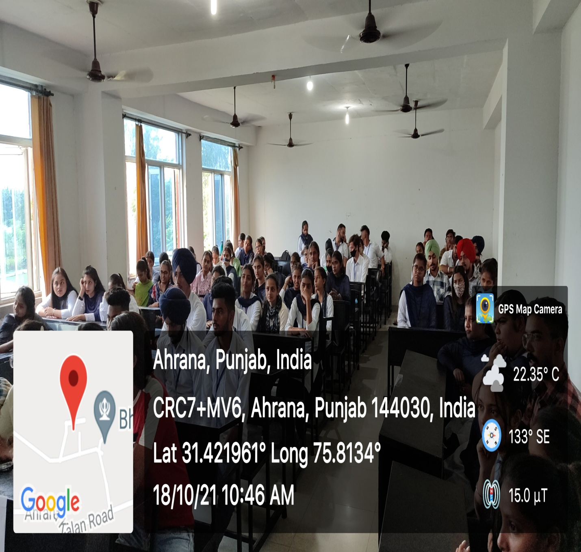
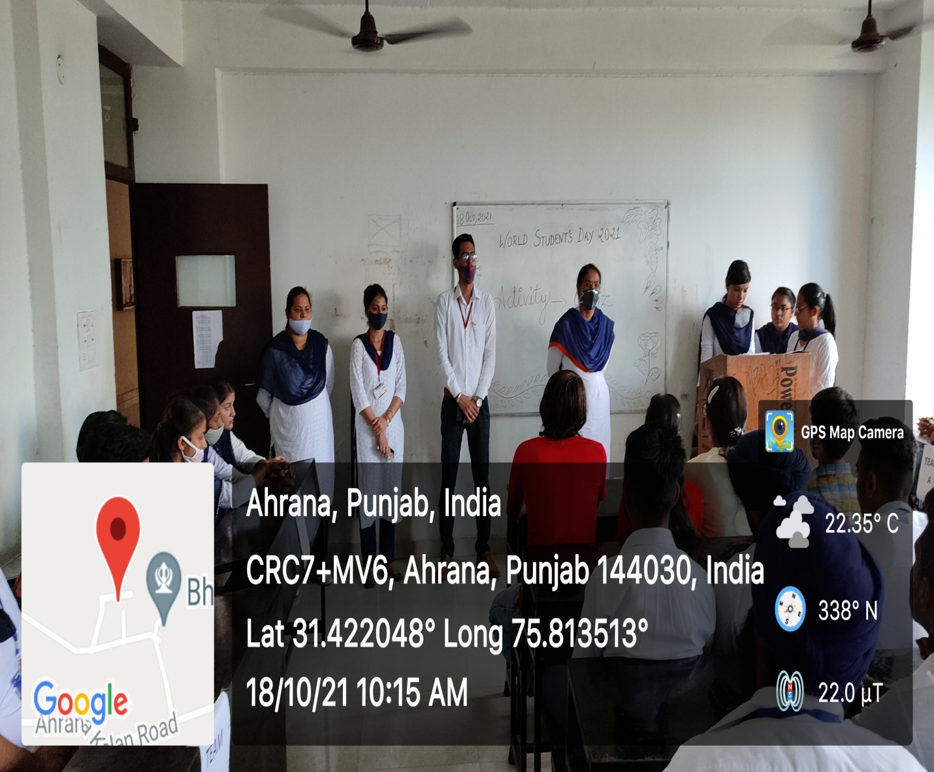
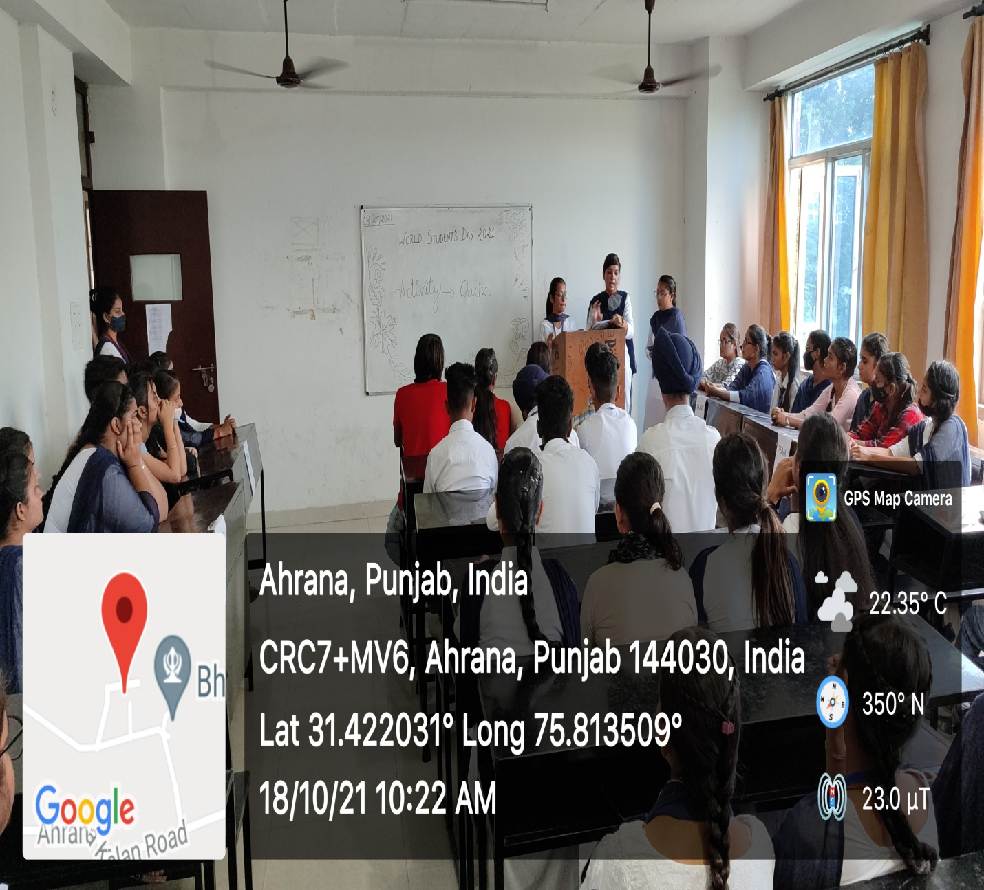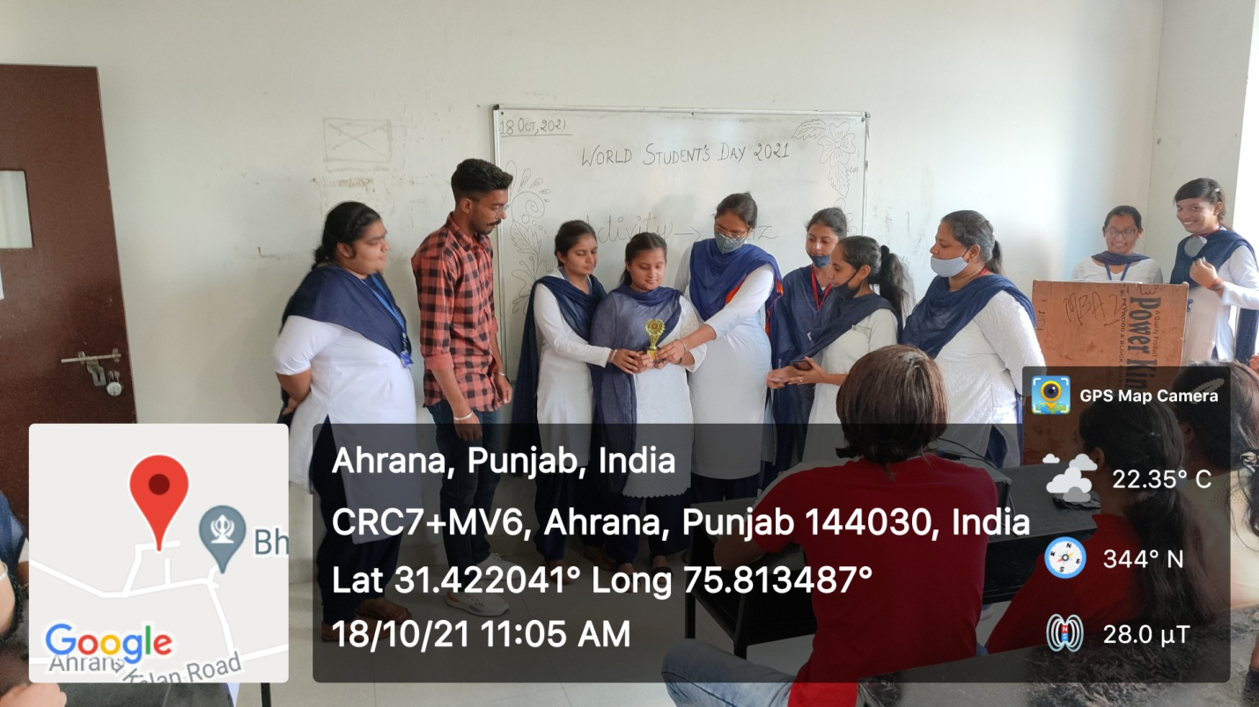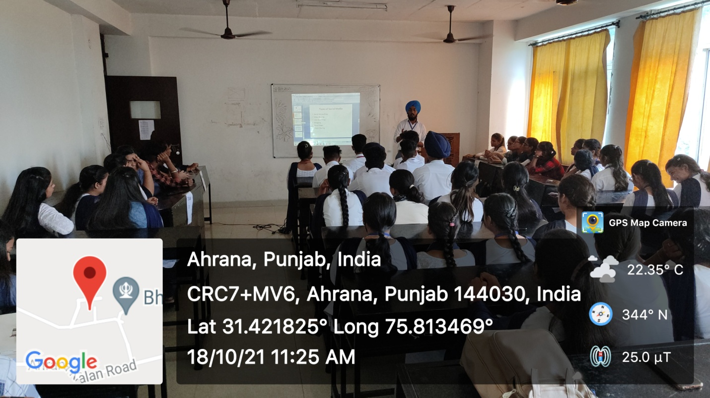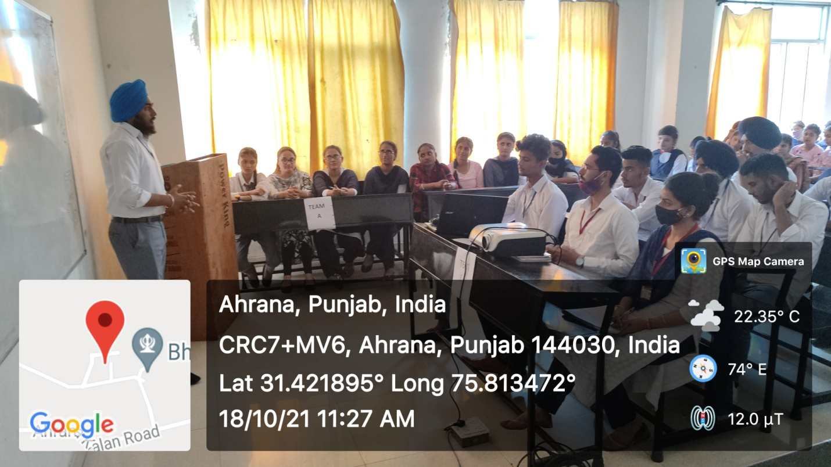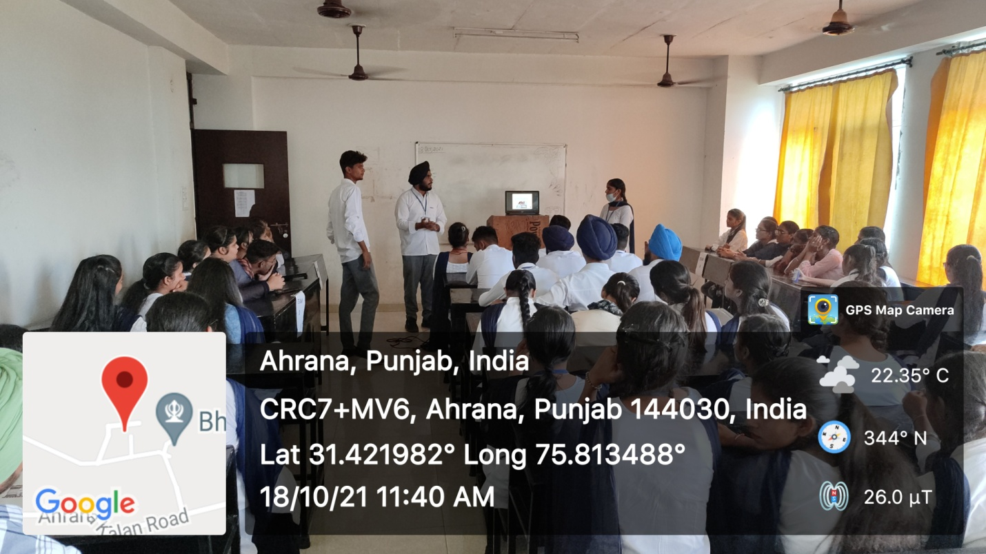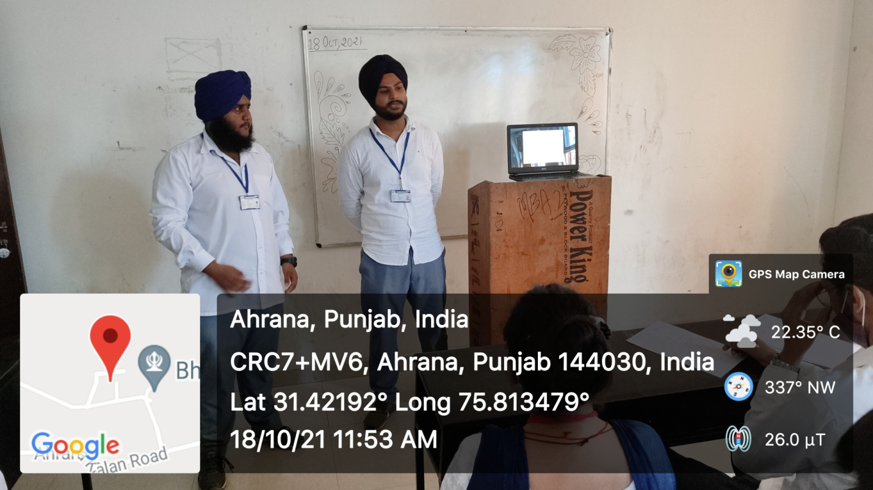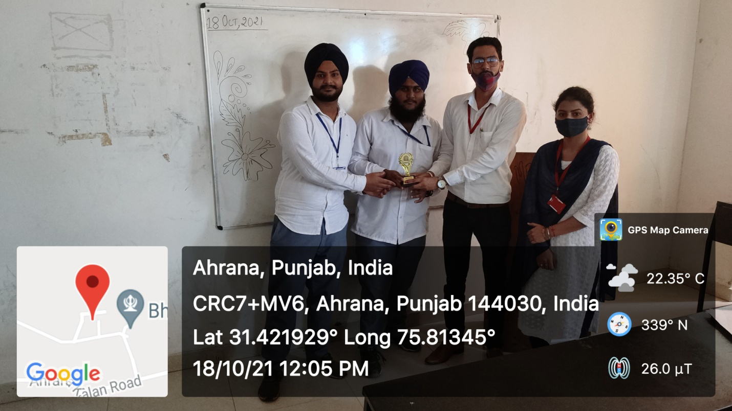

Event Organizers : All Faculty of the UICM

